**HCMC UNIVERSITY OF TECHNOLOGY AND EDUCATION**

**FACULTY FOR HIGH QUALITY TRAINING**



**Project: Embedded Systems**

**Topic:** **Create temperature measuring circuit, display results on LCD**

**Lecturer : Từ Tuyết Hồng**

**Group’s members:**

1. **Nguyễn Đình Thiên Phước 17110062**
2. **Nguyễn Tấn Lộc 17110048**
3. **Mai Nguyễn Anh Thư 17110082**

**Contents**

Lecturer comment 3

Preface 4

Chapter 1: Overview of temperature control in life 5

1. Principle of operation of the incubators on the market. 6

a. Egg incubator GTL -1000 6

b. Egg incubator OXY GTL 240K 6

Chapter 2: Introduction of accessories 9

1. LM35 temperature sensor 9

2. Arduino uno r3 10

3. I2c 11

4. 16x2 LCD Module 12

Chapter 3: Simulation circuit on proteus 16

Chapter 4: Real circuit 17

Chapter 5: Conclusion and development direction of topic 18

# Lecturer comment

# Preface

The 21st century opens a new age, the era of science and technology requires people to constantly learn and learn to develop and progress. With the leap of science, electronic engineering that in a short time it has achieved great achievements in almost all fields in social life. Equipment and technology are increasingly innovating to contribute to improving the quality of life. Today, microcontroller devices have more and more widespread applications with the advantages of being compact, flexible and widely controllable. Microcontrollers increasingly occupy and play a very important role in control and automation technology.

Now with the need for specialization, optimization (time, space, cost), confidentiality, the proactive and flexible technology ... increasingly requires the introduction of new technologies in the field of manufacturing electronic control circuits to meet the urgent needs in electrical - electronic science.

Microcontroller technology is currently very developed, it meets the needs of many industries, industrial production, automation, in life ... Compared with digital, microcontroller technology is small. Therefore, it is integrated and programmable to control so it is convenient and maneuverable LCD display time.

The topic is designed based on knowledge learned, reference books and some other resources. However, due to the limited time and level, we cannot avoid our mistakes. Therefore, I hope you and your friends will have suggestions and help to improve the topic.

We sincerely thank you!

# Chapter 1: Overview of temperature control in life

Temperature is a physical quantity associated with our lives. It affects all aspects of life. And in the manufacturing fields, too, temperature directly affects the operation and production process.

In the industrial manufacturing sector, the temperature has a direct impact on the quality of the output as in the welding process of the material, the temperature affects the accuracy and the thermal expansion of the material. During the baking and drying process such as brick burning, the temperature affects the quality of the output product's hardness, flexibility, and color. In medicine, temperature affects research and treatment results. In life, temperature affects the quality and preservation of food and food. In agriculture, too, temperature directly affects agricultural results and productivity .... With these requirements, our team would like to design the topic of temperature stability with a stable temperature and control is 0 to 60 degrees C using LM35 sensor, LCD display.

Advantages: The LM 35 sensor is a relatively inexpensive wall cam and is sold on the market, with a temperature measurement range that meets the requirements of the topic.

With the subject of a successful incubator, the requirement of temperature stability is very important to the success of the incubation process. On request, the temperature in the blender furnace ensures a 2 ° C difference from the required temperature.

## Principle of operation of the incubators on the market.

The 100% automatic incubators are controlled by a main control module. This module receives operating information from the thermal sensor module, then transmits the signal to control the heating module. In addition, the egg filling machine also has a module to set the incubation temperature, incubation time - Some of the following incubators:

### Egg incubator GTL -1000

GTL -1000 fully automatic egg incubator, maximum capacity of 1000 eggs, automatic egg reversing (timer), humidity spray and custom temperature automatically close when passing specified number

* Voltage: 220V AC
* Power consumption: 10kw / 1 period

**Structure:**

* Fumigation: Custom, automatically shut off when over % prescribed
* Heat supply system: Halozen heat bulb dedicated to incubating eggs
* Rotate the eggs: Self-timer from 30 minutes - 120 hours
* Temperature is automatically controlled, stable by microprocessor
* Automatic humidification
* Automatic egg rotation (you can choose time from hour to 120 hours)
* Can incubate in multi-cycle mode (once a week on eggs) or single cycle

### Egg incubator OXY GTL 240K

* The egg incubator with gas
* Voltage: 220V AC
* Power consumption: 2kw electricity / 1 incubation period
* The thermistor supply system
* The temperature is automatically controlled by microprocessor
* Automatic oxygen mixing
* Can be incubated in multi-cycle, or single-cycle mode

**Pictures of some incubators on the market:**

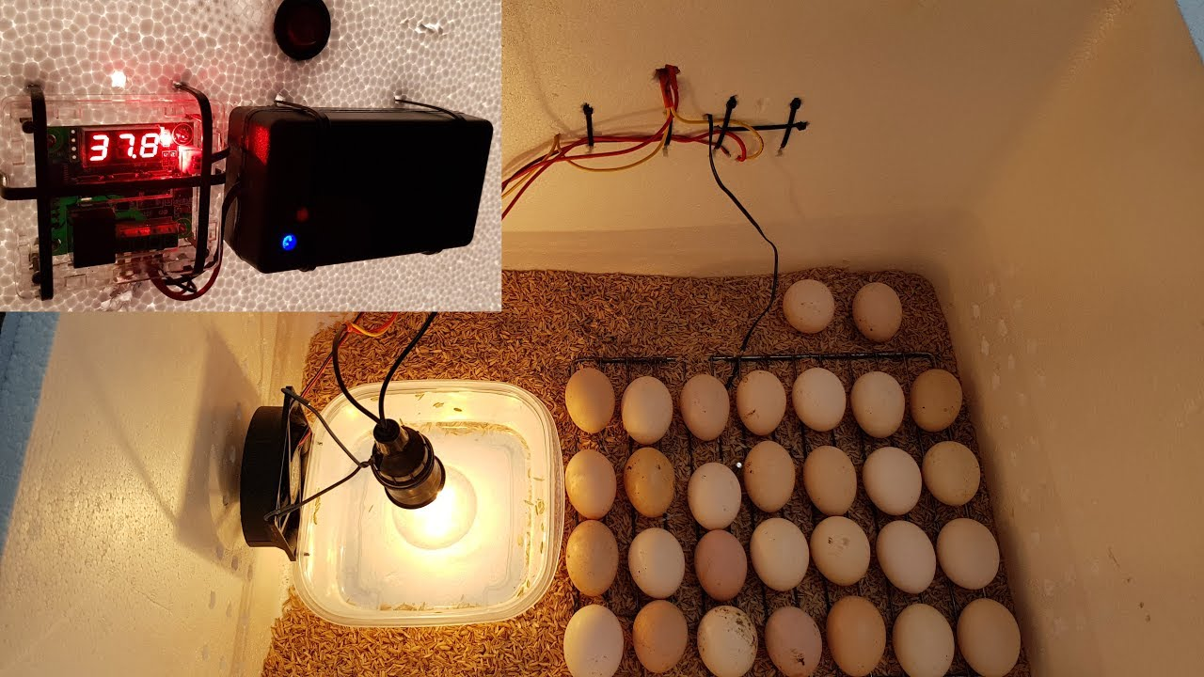

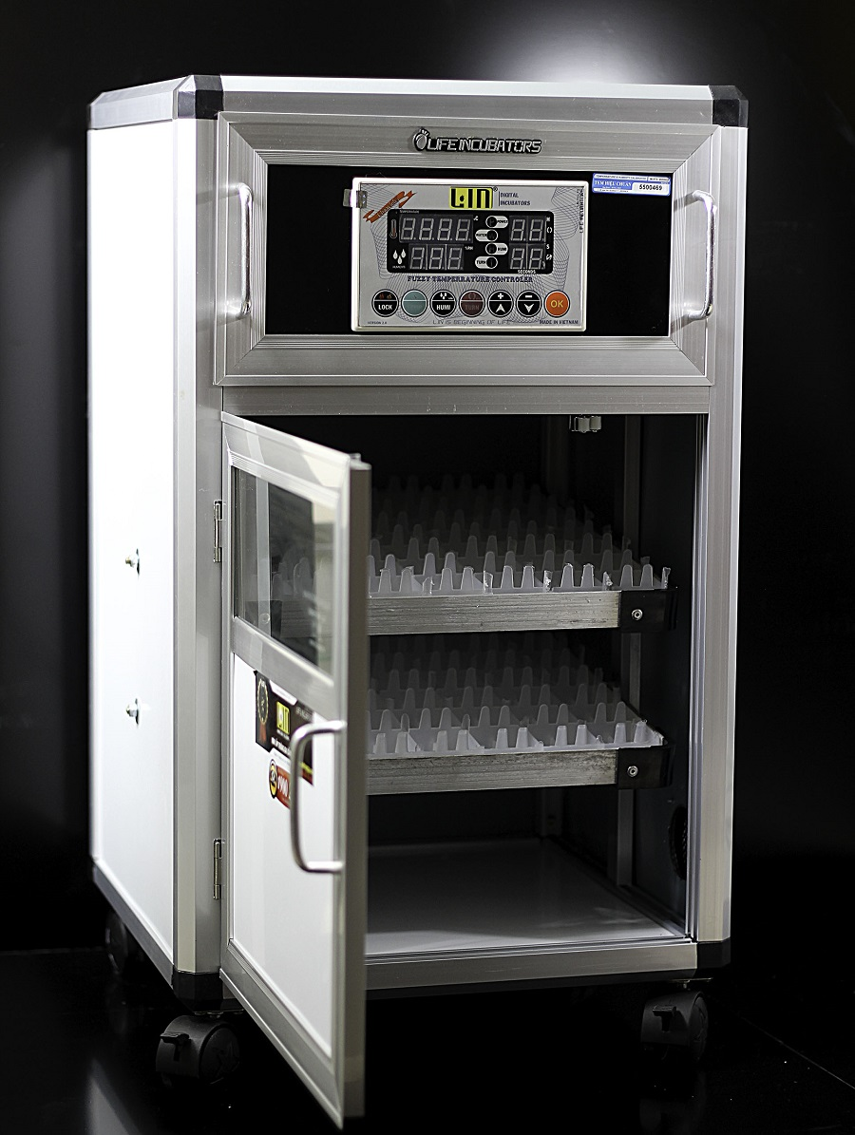

# Chapter 2: Introduction of accessories

## LM35 temperature sensor

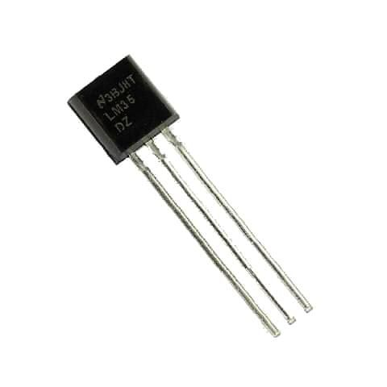

LM35 has 3 pins: 2 pins for power supply and 1 pin to output voltage depending on the temperature

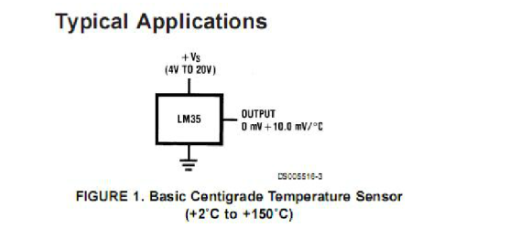

When the temperature increases by 1 C, the output voltage at the output pin of LM35 increases by 10mV.

**Other specifications:**

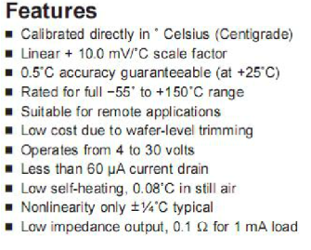

## Arduino uno r3

The Arduino Uno R3 is a microcontroller board based on a removable, dual-inline-package (DIP) ATmega328 AVR microcontroller. It has 20 digital input/output pins (of which 6 can be used as PWM outputs and 6 can be used as analog inputs). Programs can be loaded on to it from the easy-to-use Arduino computer program. The Arduino has an extensive support community, which makes it a very easy way to get started working with embedded electronics. The R3 is the third, and latest, revision of the Arduino Uno.

**Specifications:**

* It is an ATmega328P based Microcontroller
* The Operating Voltage of the Arduino is 5V
* The recommended input voltage ranges from 7V to 12V
* The i/p voltage (limit) is 6V to 20V
* Digital input and output pins-14
* Digital input & output pins (PWM)-6
* Analog i/p pins are 6
* DC Current for each I/O Pin is 20 mA
* DC Current used for 3.3V Pin is 50 mA
* Flash Memory -32 KB, and 0.5 KB memory is used by the boot loader
* SRAM is 2 KB
* EEPROM is 1 KB
* The speed of the CLK is 16 MHz
* In Built LED
* Length and width of the Arduino are 68.6 mm X 53.4 mm
* The weight of the Arduino board is 25 g

## I2c

The Inter-Integrated Circuit (I2C) module is a serial interface useful for communicating with other peripheral or microcontroller devices. These peripheral devices may be serial EEPROMs, display drivers, analog-to-digital converters, etc…

The I2C module can operate in any one of the following I2C systems:

* As a slave device
* As a master device in a single master system (slave may also be active)
* As a master or slave device in a multi-master system (bus collision detection and arbitration available)

The I2C module contains independent I2C master logic and I2C slave logic, each generating interrupts based on their events. In multi-master systems, the software is simply partitioned into a master controller and a slave controller.

When the I2C master logic is active, the slave logic also remains active, detecting the state of the bus and potentially receiving messages from itself in a single master system or from other masters in a multi-master system. No messages are lost during multi-master bus arbitration.

In a multi-master system, bus collision conflicts with other masters in the system are detected and reported to the application (BCOL interrupt). The software can terminate, and then restart the message transmission.

The I2C module contains a Baud Rate Generator (BRG). The I2C BRG does not consume other timer resources in the device. Key features of the I2C module include the following:

* Independent master and slave logic
* Multi-master support, which prevents message losses in arbitration
* Detects 7-bit and 10-bit device addresses with configurable address masking in Slave mode
* Detects general call addresses as defined in the I2C protocol
* Automatic SCLx clock stretching provides delays for the processor to respond to a slave data request
* Supports 100 kHz and 400 kHz bus specifications
* Supports strict I2C reserved address rule

## 16x2 LCD Module

**Pin Configuration**

|  |  |  |
| --- | --- | --- |
| **Pin No:** | **Pin Name:** | **Description** |
| 1 | Vss (Ground) | Ground pin connected to system ground |
| 2 | Vdd (+5 Volt) | Powers the LCD with +5V (4.7V – 5.3V) |
| 3 | VE (Contrast V) | Decides the contrast level of display. Grounded to get maximum contrast. |
| 4 | Register Select | Connected to Microcontroller to shift between command/data register |
| 5 | Read/Write | Used to read or write data. Normally grounded to write data to LCD |
| 6 | Enable | Connected to Microcontroller Pin and toggled between 1 and 0 for data acknowledgement |
| 7 | Data Pin 0 | Data pins 0 to 7 forms a 8-bit data line. They can be connected to Microcontroller to send 8-bit data.  These LCD’s can also operate on 4-bit mode in such case Data pin 4,5,6 and 7 will be left free. |
| 8 | Data Pin 1 |  |
| 9 | Data Pin 2 |  |
| 10 | Data Pin 3 |  |
| 11 | Data Pin 4 |  |
| 12 | Data Pin 5 |  |
| 13 | Data Pin 6 |  |
| 14 | Data Pin 7 |  |
| 15 | LED Positive | Backlight LED pin positive terminal |
| 16 | LED Negative | Backlight LED pin negative terminal |

**Features of 16×2 LCD module**

* Operating Voltage is 4.7V to 5.3V
* Current consumption is 1mA without backlight
* Alphanumeric LCD display module, meaning can display alphabets and numbers
* Consists of two rows and each row can print 16 characters.
* Each character is build by a 5×8 pixel box
* Can work on both 8-bit and 4-bit mode
* It can also display any custom generated characters
* Available in Green and Blue Backlight

**16x2 Display Equivalents:** Dot Matrix LED Display, 7-Segment LED Display, OLED Display, TFT LCD Screen Display

**Brief Description on LCD modules**

LCD modules are very commonly used in most embedded projects, the reason being its cheap price, availability and programmer friendly. Most of us would have come across these displays in our day to day life, either at PCO’s or calculators. The appearance and the pinouts have already been visualized above now let us get a bit technical.

16×2 LCD is named so because; it has 16 Columns and 2 Rows. There are a lot of combinations available like, 8×1, 8×2, 10×2, 16×1, etc. but the most used one is the 16×2 LCD. So, it will have (16×2=32) 32 characters in total and each character will be made of 5×8 Pixel Dots.  A Single character with all its Pixels is shown in the below picture.

16x2 LCD Pixel

Now, we know that each character has (5×8=40) 40 Pixels and for 32 Characters we will have (32×40) 1280 Pixels. Further, the LCD should also be instructed about the Position of the Pixels. Hence it will be a hectic task to handle everything with the help of MCU, hence an **Interface IC like HD44780**is used, which is mounted on the backside of the LCD Module itself. The function of this IC is to get the **Commands and Data** from the MCU and process them to display meaningful information onto our LCD Screen. You can learn how to interface an LCD using the above mentioned links. If you are an advanced programmer and would like to create your own library for interfacing your Microcontroller with this LCD module then you have to understand the HD44780 IC is working and commands which can be found its datasheet.

# Chapter 3: Simulation circuit on proteus

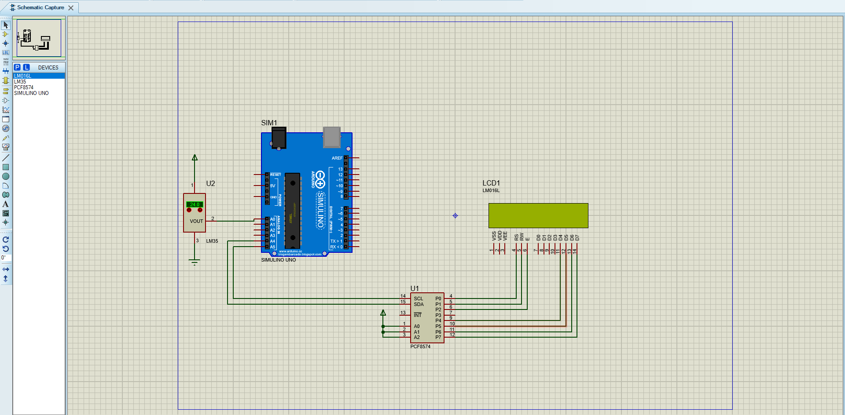

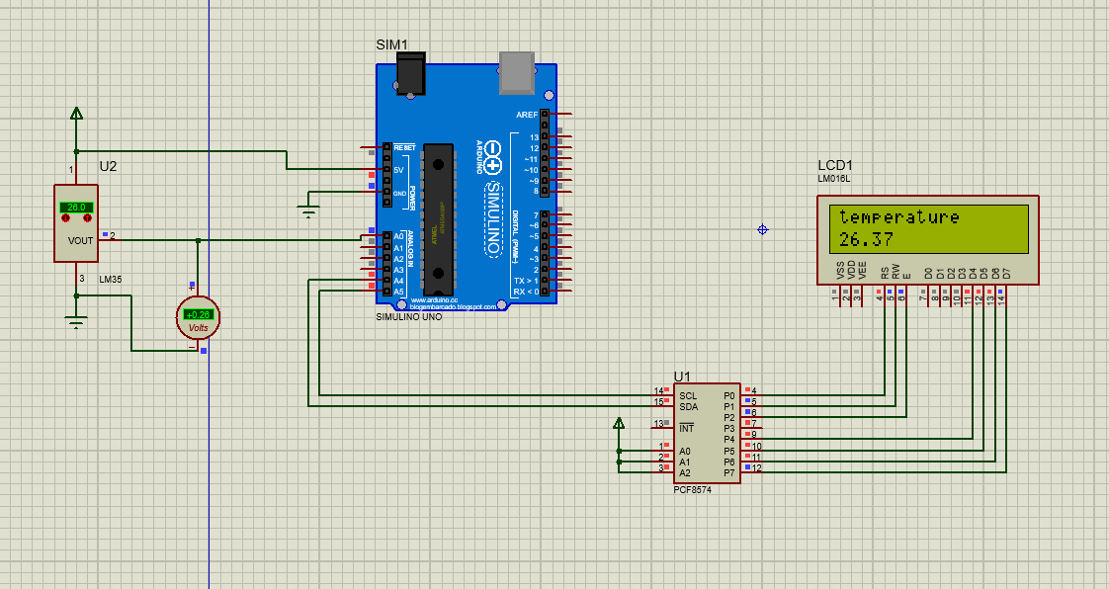

# Chapter 4: Real circuit

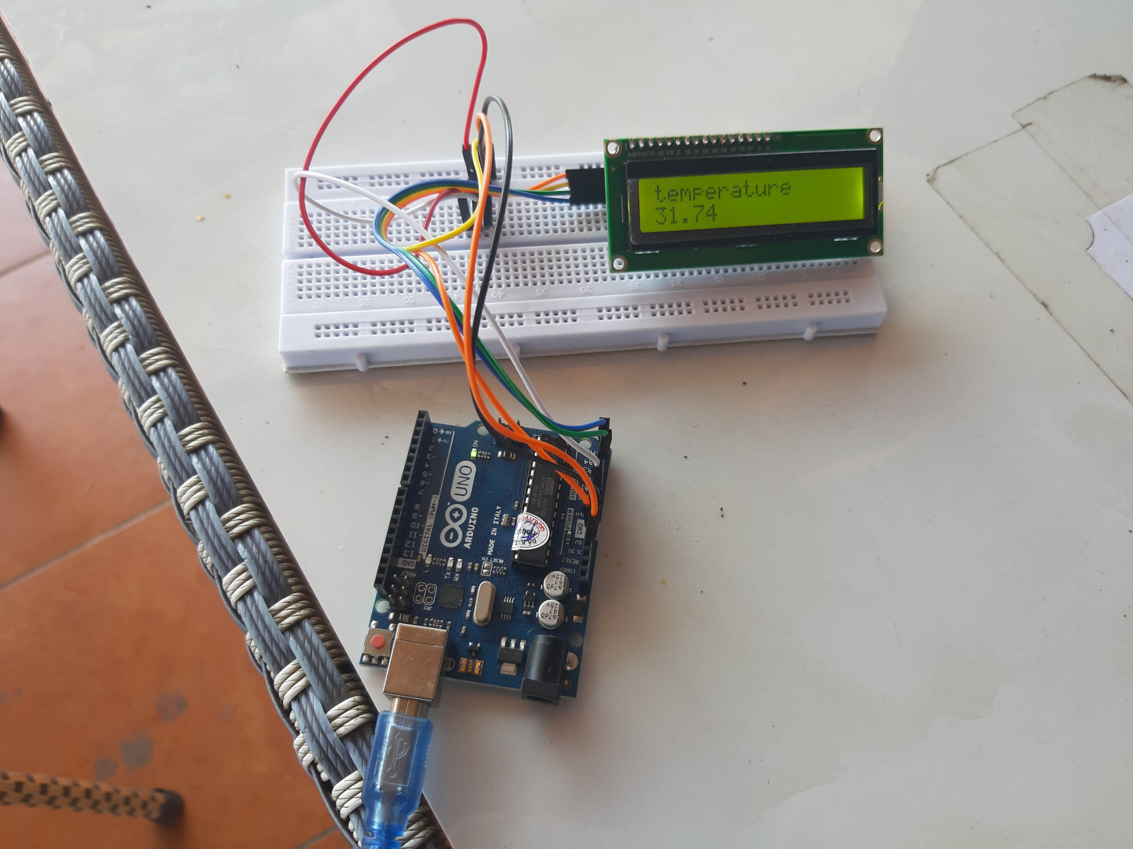

The actual circuit is used to measure the temperature of the surrounding environment.

# Chapter 5: Conclusion and development direction of topic

After a period of research and enthusiastic guidance of Ms. Tu Tuyet Hong we have completed the project " Create temperature measuring circuit, display results on LCD ". We have run the test and the results are satisfactory.

For this topic we have applied a small part of the Arduino uno r3 microcontroller.

During the implementation of this project, we have obtained the following results:

* More learning and more knowledge.
* Capable of analyzing, designing and constructing a complete product.

However, with the time allowed as well as limited knowledge, the project still has shortcomings.

Once again, we would like to thank Ms. Tu Tuyet Hong for enthusiastically guiding and imparting knowledge throughout the learning process and implementing this project.